ECOSPACE guidelines

Purpose
This document provides guidelines for configuring, and running external time series of maps in Ecospace, the spatial-temporal module of the Ecopath with Ecosim (EwE) software. This document was written using EwE version 6.6 Beta 4, March 2019.

Using the Spatial Temporal Framework
The spatial temporal framework is a plug-in to the EwE 6 software, built with the sole purpose to dynamically insert (time varying) spatial data that is external to the EwE model into Ecospace map layers (Steenbeek et al., 2013).
The framework integrates with the EwE6 user interface in several locations as shown below (Figure 1).
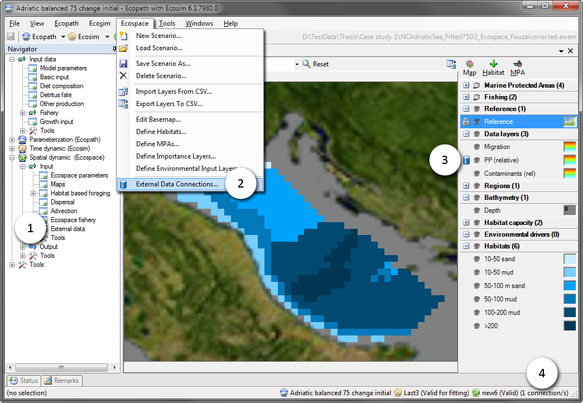
Figure 1 - The EwE6 user interface, with indications to the presence of the external spatial data facilities: (1) an item in the EwE navigation tree, (2) a configuration option in the Ecospace menu, (3) a blue database icon beside each map layer in the Ecospace map interface to indicate this layer is connected to external data, and (4) a the number of external data connections summarized in the EwE status bar.

Connections
A ‘connection’ is the link between an Ecospace map layer and a repository of maps (or time series of maps) that are not stored within the EwE model. Connections are defined by the EwE user, and can be shared across computer systems.
Connections are managed from the central “Define external spatial temporal connections“ screen (Figure 2), which is accessible from several locations throughout Ecospace. Here, users can create and delete connections of different types, manage in which file the connections are stored on the local machine, export connections and their data for sharing with other users, and control whether the framework is allowed to dedicate background processing time to index the spatial and temporal overlap of external data with the current Ecospace scenario.
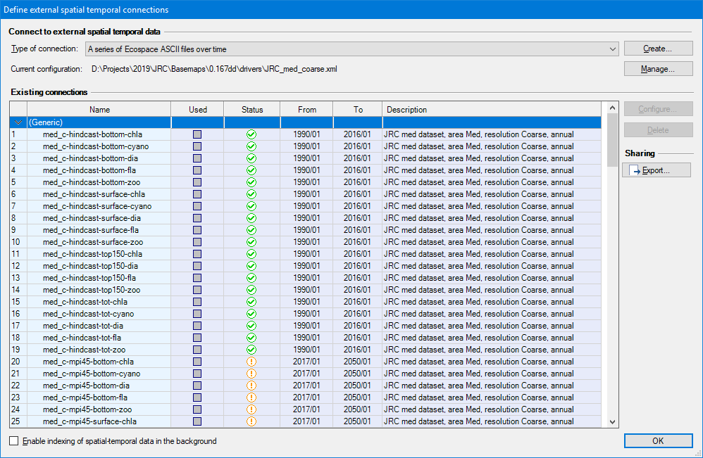
Figure 2 - Define external spatial temporal connections screen
Existing connections are briefly summarized. The Used column states if the connection is actually applied to one or more Ecospace layers. The Status column uses icons to explain whether the connection has errors ( ), has only partial spatial overlap with the modelled area ( ), or entirely covers the modelled area ( ). The warning icon is also used to notify that data compatibility has not been assessed yet, which can be done by enabling indexing or by running Ecospace, in case each used connection is automatically validated.
To define a new connection:
- Go to Menu > Ecospace > Define external data connections…
- Select the type of connection to create. At time of writing, four file-based connection types are supported: (1) a time series of ASCII files which must be prepared to match the spatial extent and cell size of a dedicated Ecospace scenario; (2) a time series of spatial files which will be made fit for inclusion in Ecospace by the DotSpatial / GDAL GIS engine encapsulated in the spatial temporal data framework; (3) a file with X,Y,Z,T time series values provided in CSV file format, where (X,Y) coordinates can either indicate (column, row) or (longitude, latitude); and (4) a single spatial file.
- Press Create…. A new connection is defined, and the “Configure external data connection view” opens up (Figure 3) to allow its content to be modified.

The configuration process of file-based connections is straight forward:
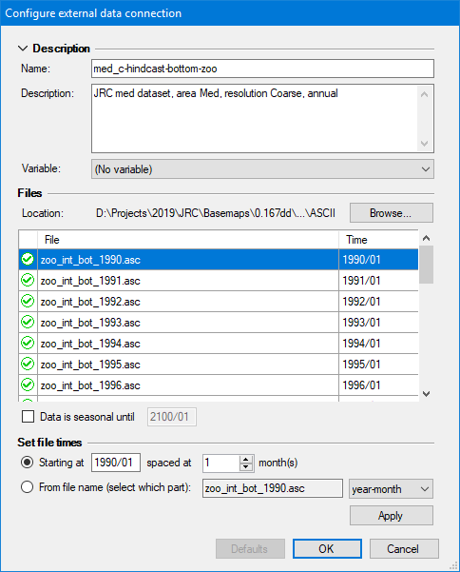
- Enter a name that identifies its content, keeping in mind that you may have a large number of connections to sift through. To illustrate, this Mediterranean modelling exercise featured 150 different connections per scenario.
Figure 3 - Configure external data connection screen, where users configure a time series of external maps
- Enter a description to state data source, spatial and temporal resolution, data pedigree, and other details, considering one may have many connections to manage.
- Optionally, select the Ecospace variable the connection is limited to. This does NOT assign the connection; it only limits where this connection is available in the EwE user interface.
- Press Browse to select which files belong to the connection browse to the folder where the files reside, and select and insert the desired files. The files list will populate in response. Note that each file represents a map in time. times can be entered by hand, or can be set automatically, either by entering a start date (year/month) and monthly interval, or by reading the time step from a fixed position in the file names. Seasonal data rotates the first year of data until the indicated end date.
- Press OK

Assigning external data to Ecospace
To make external connections operational in Ecospace, do the following:
- Go to Navigator > Ecospace > Input > External data… The External data view opens up (Figure 4), and displays all Ecospace map layers that can receive external data. The toolbar offers options to limit the number of layers on display, with filters by layer type, and only viewing layers with active connections. The external data interface also shows a time line that reflects the temporal overlap of external data with the Ecospace scenario.
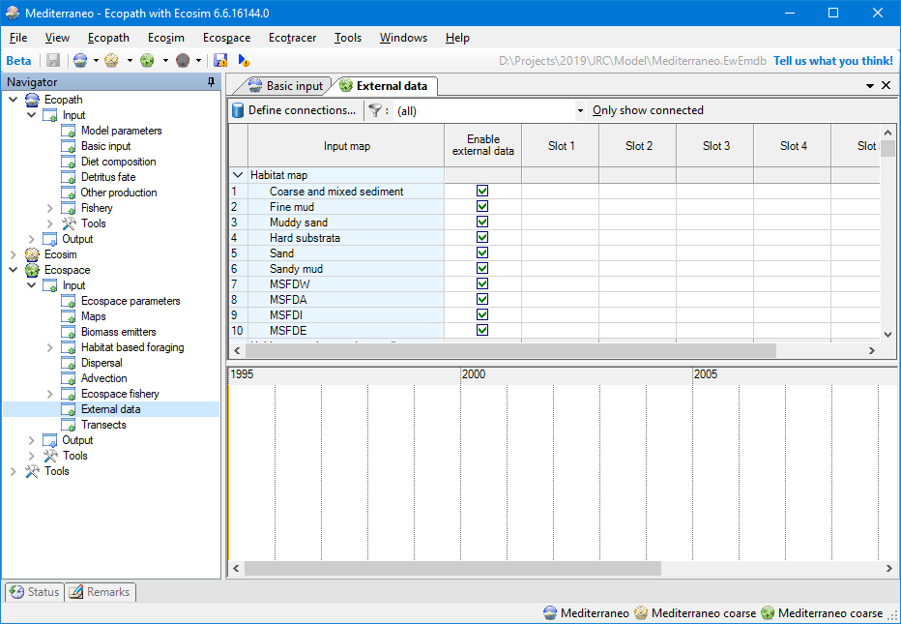
Figure 4 - External data view, which provides an overview which Ecospace layers have external data assigned to them
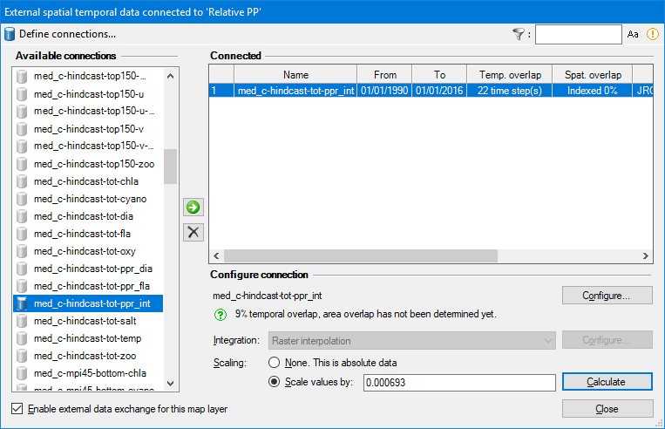
Every map layer has up to six slots for assigning connections. To assign external data to a layer:
Figure 5 - Assign connection interface, where an external data connetion is assigned to a single Ecospace map layer.
- Click the first available slot in the layer that you wish to assign external data to. This opens up the Assign connection interface (Figure 5)
- Select a connection from the list of available connections
- Click the use button ( ) to assign the connection. A configuration panel opens with additional options. Available options depend on the type of connection that was selected, and the type of Ecospace layer the connection is applied to. Some Ecospace layers may require data to be scaled, for instance, and for those layers you will need to provide a scalar. The configuration panel also summaries compatibility of assigned external data with the current Ecospace scenario.
- Click Configure to review or change the configuration of the connection (as explained above).
- Select an Integration method if applicable, which are geospatial macros that convert data to the desired Ecospace layer needs.
- Enter a scaling method if applicable
- Enter a scaling factor, which can be left at default 1 if data in the Ecospace scenario is the same as the first month of external data.
- Calculate the scaling factor to scale the first year of external data scales to an Ecopath base value (this is highly recommended when driving the Relative PP layer, for instance).
- Press Close to make the external data connection stick, and save the model.
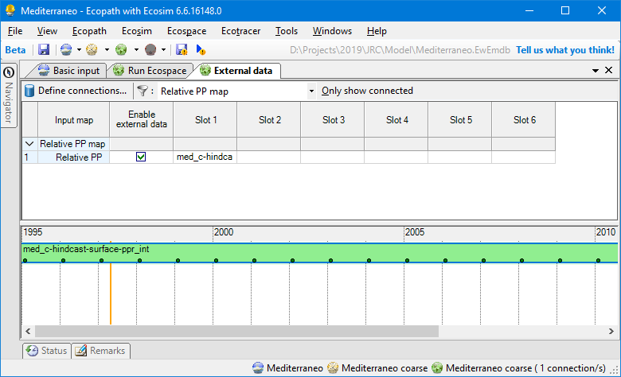
Figure 6 - The external data view with External data assigned to drive the content of the Ecospace “Relative PP” layer

Running Ecospace with external data
When Ecospace is executed as normal, the EwE status panel will show a notification every time external data is accessed and whether integration into the intended Ecospace layer was successful. These notifications are also written to an extensive log file, which is written to the same directory where the EwE model is located. This file can be helpful for troubleshooting external data connection issues.
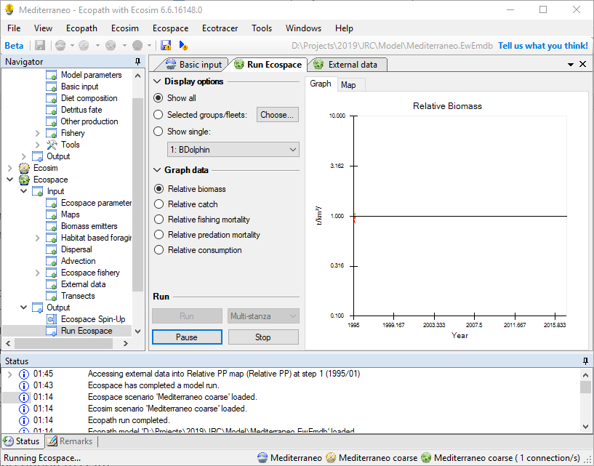
Figure 7 - Run Ecospace interface and the EwE status panel. The status panel informs users when Ecospace has attempted to integrate external data into the running model
If Ecospace has encountered any issue with external data during a run, it will notify the user that issues were encountered. As the Ecospace run missed some needed external data it should not be trusted, and the status panel and/or spatial log file will provide clues as to why needed spatial data was not found.

Configuration files
All spatial temporal data connection definitions are stored in configuration files. At any given moment, EwE operates on only one configuration file that defines available external data connections. This central storage allows external connections to be reused between Ecospace modelling exercises, and provides a means to organize how much data is visible to a specific modelling exercise.
Configuration files are managed in Menu > Tools > Options > External data… Here, one can create or delete configuration files (in .xml format), add an existing configuration file to EwE, and set the active configuration file.
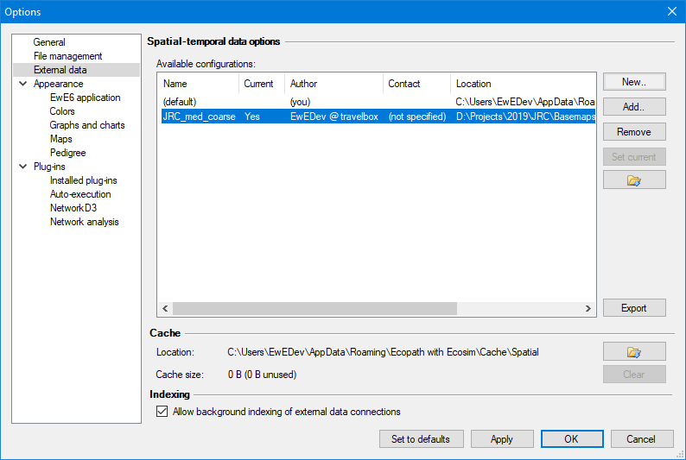
Figure 8 - The form where users can switch external data configuration files. Use this only when you run multiple projects at the same time, each requiring numerous external data connections
Once a connection is applied to an Ecospace layer, the definition of the connection is stored within Ecospace, while the data remains outside the model.
It is advisable to use separate configuration files for different models, as the number of external spatial temporal data connections can become overwhelming.

Sharing definitions external data with other computers or users
The export external spatial data interface, which can be launched from all locations in the EwE user interface where external data connections are managed, creates new configuration files from selected external data connection definitions, and optionally their data. All exported data is placed in a user-selected folder.
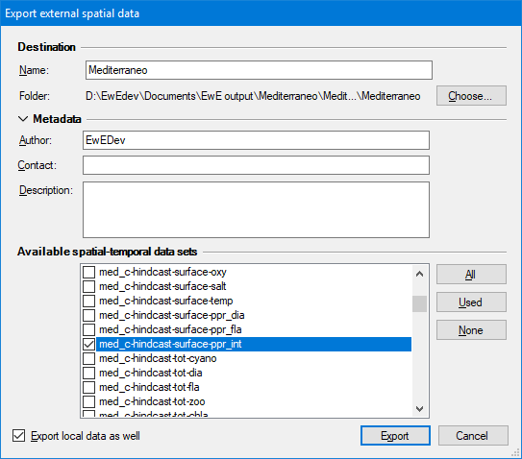
To share external data connected to your model with another computer or user:
- Open the export external spatial data view, for instance through Menu > Tools > Options > External data > Export
- Enter a descriptive file name (such as “External data Med 0.01667dd”)
- Select Choose to browse to the a location where the exported data can be placed
- Select which connections to export. The “Used” button selects all connections assigned in Ecospace; the “All” button selects all available connections as defined the current configuration file.
- Check “Export local data as well”
- Click Export. Please be patient, this may take a while.
Figure 9 - Figure 9 - The Export external data interface
Once the export process is complete, share the data as follows:
- Give the entire exported folder with your model to another modeler. One can also place the exported folder on a shared network drive
To incorporate shared data into EwE:
- Go to Tools > Options > External data
- Click Add
- Browse to the shared configuration file
- Press Open and the configuration file will be added to EwE
- Press “Set Current” to make this the active configuration file
- Load Ecospace. When an Ecospace scenario is loaded, the spatial temporal data framework automatically resolves conflicts in external data connections against the current configuration file.

